描述符desc在NVDLA的软件栈中占有很大作用，不论是操作operation的op_desc，还是表面surface的surface_desc，还是状态status的stat_desc，还是网络network的network_desc等，我们这个部分就介绍一些与这些描述符相关的数据结构data structure以及相关的一些处理函数。

下面的表格列举了所有的（后面会更新该表格）与desc相关的数据结构和操作函数。

|  |  |  |  |
| --- | --- | --- | --- |
| 数据结构 | 概述 | 处理函数 | 概述 |
| dla_common_op_desc |  | dla_get_op_desc |  |
| dla_roi_desc |  | dla_put_op_desc |  |
| dla_roi_array_desc |  | dla_free_op_desc |  |
| dla_bdma_transfer_desc |  | dla_dump_op_desc |  |
| dla_bdma_surface_desc |  | dla_debug_op_desc |  |
| dla_bdma_op_desc |  | dla_debug_network_desc |  |
| dla_bdma_stat_desc |  |  |  |
| dla_conv_surface_desc |  |  |  |
| dla_conv_op_desc |  |  |  |
| dla_conv_stat_desc |  |  |  |
| dla_sdp_surface_desc |  |  |  |
| dla_sdp_op_desc |  |  |  |
| dla_sdp_stat_desc |  |  |  |
| dla_pdp_surface_desc |  |  |  |
| dla_pdp_op_desc |  |  |  |
| dla_pdp_stat_desc |  |  |  |
| dla_cdp_surface_desc |  |  |  |
| dla_cdp_op_desc |  |  |  |
| dla_cdp_stat_desc |  |  |  |
| dla_rubik_surface_desc |  |  |  |
| dla_rubik_op_desc |  |  |  |
| dla_rubik_stat_desc |  |  |  |
| dla_network_desc |  |  |  |
| drm_buf_desc |  |  |  |
| nvdla.TensorDesc |  |  |  |
| NvDlaTensorDesc |  |  |  |
| NvDlaMemDesc |  |  |  |
|  |  |  |  |

dla_common_op_desc结构体是操作operation的通用描述符，包括index，roi_index，op_type，dependency_count，以及consumers和fused_parent六个成员。由该结构体例化的变量有desc_cache[DLA_OP_NUM][DLA_OP_CACHE_SIZE]；结构体dla_processor_group的成员dla_common_op_desc *op_desc，dla_common_op_desc *consumers[DLA_OP_NUM]，dla_common_op_desc *fused_parent；和结构体dla_processor的成员dla_common_op_desc *tail_op。

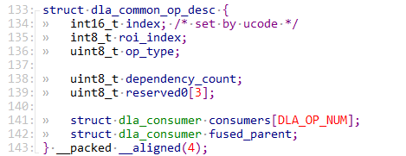

dla_roi_desc结构体和dla_roi_array_desc结构体，这两个结构体都比较简单，成员函数也没有嵌套其他结构体，含义也就较为明确。

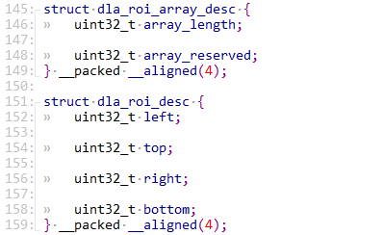

与BDMA相关的描述符，包括dla_bdma_transfer_desc，dla_bdma_surface_desc，dla_bdma_op_desc，dla_bdma_stat_desc四个。首先是dla_bdma_transfer_desc结构体，主要包括传输的源和目的地址，line和surface相关的源和目的以及重复次数。而dla_bdma_surface_desc结构体就需要指明源和目的的类型以及传输次数，目前支持的类型有两种，DMA或者PROCESSOR。dla_bdma_op_desc结构体主要是就是指出传输次数。而dla_bdma_stat_desc给出读写是否停顿以及是否在运行等状态信息。

